A Map of the Region that you choose  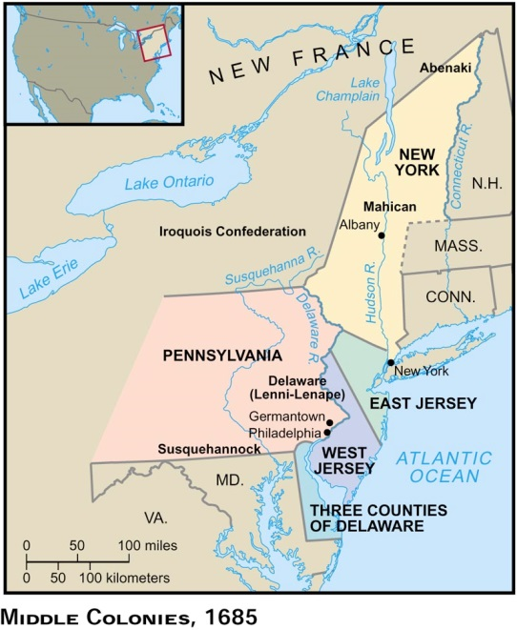  You must include a map of the region in which you are creating your travel brochure.  This map should be:  - Labeled with colony names  - Labeled with major cities in your region  - Labeled with the waterways in your region  On this page you must also include:  - A minimum of three sentences as to why people living in England should move to your region.  How was your colony Established?  Pick ONE colony from your region and answer the following:  You may bullet out the important information about how ONE of the colonies in your region was formed. You must use complete sentences  You must include:  - When was your colony established?  - Who founded your colony?  - WHY was your colony established?  - What region is your colony in?  - What was the purpose of your colony during that time period?  - What hardships did your colonists overcome to have a successful colony?  ALWAYS INCLUDE PICTURES!  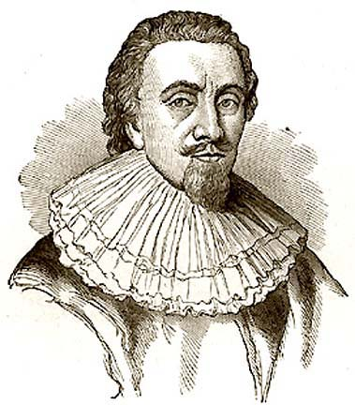  You may want to include captions to explain your pictures as well. For example, this is Lord Baltimore who was one of the founders of Maryland. | Major Cities and Income (Jobs) of your region  On this page of your brochure you should include TWO parts.  Part I:  - Major Cities in your Region  - You may bullet these cities. In addition to listing the city write ONE sentence that would attract tourists  - Example:  - New York City is a large city that is located on the water, making travel into and out of New York very easy.  Part II:  - This is the INCOME or jobs of the colonists living in your region. Please refer to your map for this.  - You may bullet these points as well.  - Example:  - In the Middle Colonies, there are many different types of jobs. Including:  - Fishing  - Cattle raising  - Lumberjacking  - Producing Rum  ALL TRAVEL BROCHURES INCLUDE PICTURES!  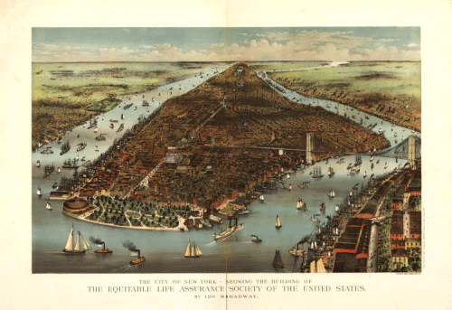  Natural Resources of your Region  Remember, you are trying to get people from England to move into your region. You are going to want to highlight all of the natural resources that they will be able to take advantage of when they move to your Region.  This section may be bulleted. HOWEVER, the bullets must be FULL SENTENCES that tell your reader what natural resources you have, and why they are so appealing to someone who is moving to your region.  ALWAYS INCLUDE PICTURES!  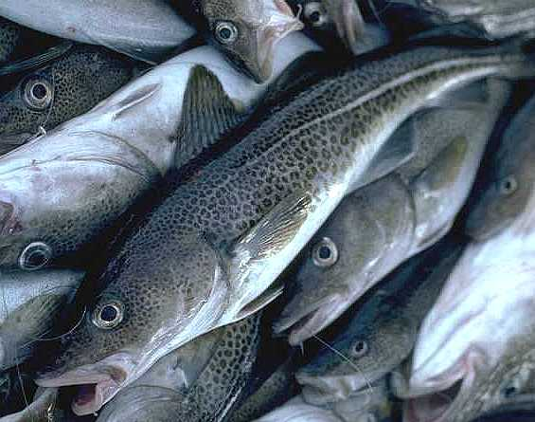  You may want to include captions underneath these pictures to help explain what they are, and why they would want to make people take a dangerous voyage across the Atlantic Ocean to move to the New World. | 13 Colonies  Travel Brochure  DUE ON______________  You will pick one of the three colonial regions and create a travel brochure for that region, in the same style of this travel brochure.  Each page must meet the requirements outlined in this handout.  For your Research  You may use the following:  - Reliable sources on the internet -- please ask me about any websites you have questions about.  - All of your class notes will guide your brochure. You may include any/all of the information you use in class.  A note on PLAGARISM. If it is discovered that you plagiarized any of this brochure, you will automatically receive a zero. If there are any questions regarding plagiarism, please see me for extra help.  This is your Cover page and should include:  - Your Name  - Your Period  - The colonial region you are advertising  - Pictures that would attract tourists to your region  Lifestyles of the Region you Choose  On this page you will give a detailed description of what life was like for people living in your region. Your GOAL is to attract more settlers to move to your region from England.  You must write a minimum of one paragraph about the lifestyle in your region. You may want to answer the following questions in your brochure:  - How do people make money in your region?  - What is the role of women in your region?  - What do children do in your region?  - What are some of the responsibilities of people living in your region?  - What do people do to have fun in your region?  - Why should people living in England move to your region?  - What makes your region unique?  ALWAYS INCLUDE PICTURES TOO!  